IMAGE 1

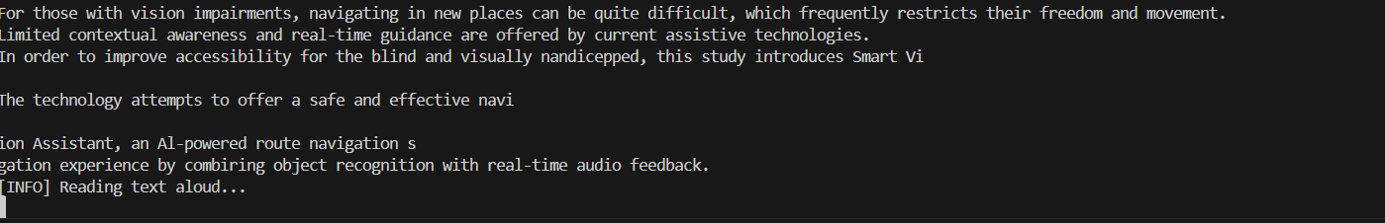

IMAGE 2

### 

### 

IMAGE 3

### 

### 

### Text-to-Speech (TTS) technology converts written text into spoken words using a speech synthesis engine. In this project, the system captures a live video frame from the IP webcam, uses Tesseract OCR to extract text from the image, and then passes the recognized text to the pyttsx3 library, which converts the text into speech using pre-installed voice engines. The engine processes the text by analyzing its structure, phonemes, and intonation, then generates synthetic speech that is played back through the system's audio output. This enables real-time auditory feedback for visually impaired users.